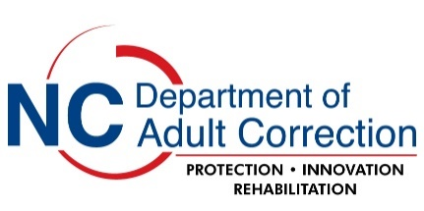
Modification Request for Approval

Project Title:

Principal Investigator:

NCDAC Project Number:

Describe the progress made to this point (include a brief paragraph that details what has been accomplished during
the period) and a summary of the changes being requested, including the rationale for modification:

NOTE: Modification of a project involving the Department of Correction (DAC) requires both IRB and DAC approval.

I am requesting modification of the project referenced above with the following changes.

a change in the number of subjects required Please describe:

a change in the facility or facilities where the research is to be conducted
Please describe:

a change to the research design Please describe:

other changes or concerns
Please describe:

_________________________________________________________________________________

Are any of these modifications due to an unexpected or adverse event? Yes No
If yes, please explain:

Attach the following documents to an email and submit to administrative-analysis@dac.nc.gov.

- A completed copy of this modification request form.

  - A revised copy of your most recent DAC Application for Research Approval document clearly indicating all of the modifications (e.g., Track changes or highlighting) you are requesting for this project.

- A copy of your official approved IRB modification approval letter from the IRB that granted original approval for the project.

If your project also requires renewal at this time, you must submit these additional documents.

  - A completed copy of the DAC Renewal Request for Approval form.

  - A copy of your official approved renewal letter from the IRB that granted original approval for the project (if IRB renewal approval is required for this project).

